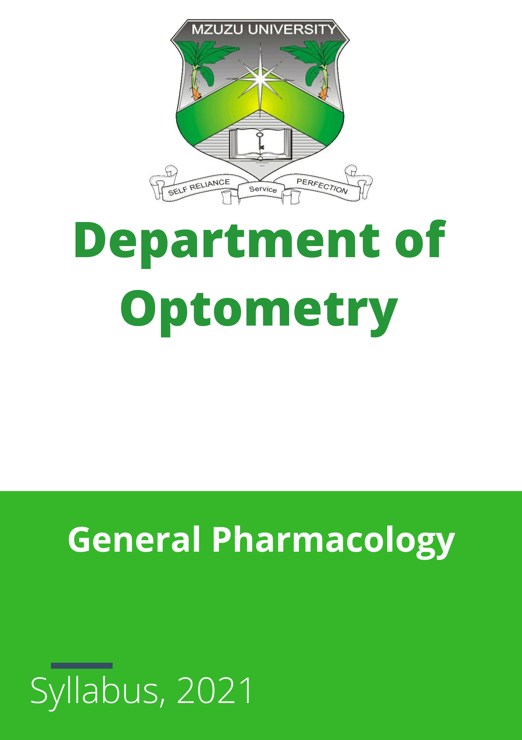
Contents
Lecture 1 General Introduction 3
Lecture 2 Legal concepts of drugs in Malawi 3
Lecture 3 Pharmacokinetics 4
Lecture 4 Pharmacodynamics 5
Lecture 5 Autonomous Nervous System Drugs (ANS) 6
Lecture 6 Cardiovascular Drugs 7
Lecture 7 Nervous System Drugs 7
Lecture 8 Endocrine System Drugs 8
Lecture 9 Cytotoxic Drugs 9
Lecture 10 Anti-Infective 10

Lecture 1 General Introduction

Aim:
To provide an overview of the history of pharmacology, the drug development process, and contemporary issues in the field.

Objectives:
By the end of this lecture, students should be able to:
- Describe the history of pharmacology.
- Explain the drug development cycle.
- Discuss contemporary issues in pharmacology, including traditional and Chinese medicine.

Time:
1 hour

Materials Required:
Prescribed textbook, notes, PowerPoint slides

Method:
Lecture videos and class discussion

Assessment:
Pop quiz, assignments, and group discussion

Scenario 1:
Scenario:
You are a member of a multidisciplinary team at a major hospital. Your team has been approached by a pharmaceutical company from China that claims to have developed a groundbreaking new drug for glaucoma. The company is eager to start a clinical trial in your hospital, and they need your approval to proceed.
Discussion Questions:
- What initial steps would you take to evaluate the credibility and safety of the new drug before considering the clinical trial?
- Identify potential ethical concerns associated with testing a new drug from a foreign company on your patients. How would you address these concerns?
- What regulatory requirements must be met before the clinical trial can begin?
- How would you ensure that the information provided by the pharmaceutical company is reliable and that the drug has undergone appropriate testing?
- Discuss the implications of using a drug that incorporates traditional and Chinese medicine principles in a modern medical setting. How would you address potential biases or skepticism from colleagues and patients?
Assignment: Write short notes on Chinese and Traditional Medicine

Lecture 2 Legal Concepts of Drugs in Malawi

Topic:
Legal Concepts of Drugs in Malawi

Aim:
To introduce students to the legal framework governing drug use in Malawi.

Objectives:
By the end of this lecture, students should be able to:
- Describe the steps involved in drug use in Malawi.
- Identify the drug regulatory bodies and explain their functions.
- Explain the legal implications of drug prescribing.

Time:
2 hours

Materials Required:
Prescribed textbook, notes, PowerPoint slides

Method:
Lecture videos and class discussion/presentation

Assessment:
Pop quiz, assignments, and group discussion

Scenario 2:
Scenario:
You have just resumed your position as an optometry intern. One of the patients is not convinced that you are allowed to prescribe drugs to her.
Discussion Questions:
- How would you respond to the patient’s concern about your ability to prescribe drugs?
- What specific legal and regulatory aspects from the lecture on the legal concepts of drugs in Malawi would you use to convince her?
- Discuss the role of drug regulatory bodies in ensuring the safety and efficacy of prescriptions. How would you communicate this to the patient?
- How can you ensure that your prescribing practices comply with the legal framework in Malawi?
- What steps would you take if a patient remains unconvinced about your qualifications to prescribe medication?

Keywords: Pharmacokinetics, preservatives, vehicles, buffer

Lecture 3 Pharmacokinetics

Topic:
Pharmacokinetics

Aim:
To provide an understanding of the fundamental principles of pharmacokinetics.

Objectives:
By the end of this lecture, students should be able to:
- Describe the routes of drug administration.
- Explain the principles of drug absorption.
- Describe bioavailability and its impact on drug action.
- Explain bioequivalence and its relevance in clinical practice.
- Track drug distribution from absorption to clearance.
- Discuss how drug treatment can be designed and optimized.

Time:
2 hours

Materials Required:
Prescribed textbook, notes, PowerPoint slides

Method:
Lecture videos and class discussion

Assessment:
Pop quiz, assignments, and group discussion

Scenario 3:
Scenario:
Mrs. Phiri has just been rushed to the emergency department after a road traffic accident. During the lunch break, an argument ensues about the best method for administering drugs to her.
Discussion Questions:
- What would be the best option for drug administration in this emergency situation?
- What factors would you consider to ensure the drug travels effectively through the chosen route?
- How would you convince your colleagues in the emergency department of the best course of action?
- Discuss the potential advantages and disadvantages of different routes of drug administration in an emergency setting.
- How does bioavailability influence the choice of drug administration in critical conditions?

Keywords: Topical, solid delivery devices, periocular, photodynamic therapy

Lecture 4 Pharmacodynamics

Topic:
Pharmacodynamics

Aim:
To explain the processes involved in pharmacodynamics.

Objectives:
By the end of this lecture, students should be able to:
- Describe signal transduction at the cell membrane.
- Explain the drug dose-response relationship.
- Differentiate between various types of agonists and antagonists.
- Illustrate the drug quantal dose-response relationship using a graph.

Time:
2 hours

Materials Required:
Prescribed textbook, notes, PowerPoint slides

Method:
Lecture videos and class discussion

Assessment:
Pop quiz, assignments, and group discussion

Scenario 4:
Scenario:
A group of secondary students visited the AVC as part of their career day activity. They would like to know how drugs work, especially at the cellular level.
Discussion Questions:
- How would you explain the mechanism of action of drugs at the cellular level in a way that secondary students can understand?
- How can drugs affect a large number of people differently?
- What role does signal transduction play in the effectiveness of a drug?
- How do different types of agonists and antagonists influence drug action at the cellular level?
- Can you provide an example of a drug dose-response relationship and explain its significance using a graph?

Keywords: Signal transduction Drug receptors Dose-response relationship Agonists and antagonists’ Quantal dose-response

Lecture 5 Autonomous Nervous System Drugs (ANS)

Topic:
Autonomic Nervous System Drugs (ANS)

Aim:
To provide an understanding of drugs affecting the autonomic nervous system (ANS).

Objectives:
By the end of this lecture, students should be able to:
- Explain the basic anatomy and physiology of the ANS.
- Describe the pharmacology of cholinergic agonists with examples.
- Describe the mechanisms and applications of cholinergic antagonists with examples.
- Describe the action and clinical use of adrenergic agonists with examples.
- Describe the pharmacology of adrenergic antagonists with examples.

Time:
4 hours

Materials Required:
Prescribed textbook, notes, PowerPoint slides

Method:
Lecture videos and class discussion

Assessment:
Pop quiz, assignments, and group discussion/presentation

Scenario 5:
Scenario:
During a social weekend, one of your roommates returns with a plate of mushrooms. The next morning, everyone who ate the mushrooms has issues with reading and feels unwell.
Discussion Questions:
- What could be the cause of these symptoms based on your knowledge of ANS drugs?
- How would you relate this situation to what you have learned in the ANS drug lecture?
- What options would be available if the problem was serious and persists?
- Discuss the potential toxic effects of certain mushrooms on the autonomic nervous system.
- How would you explain the pharmacological intervention required to counteract the symptoms caused by the mushrooms?
Keywords: ANS, Cholinergic, Adrenergic, Agonists, Antagonists

Lecture 6 Cardiovascular Drugs

Topic:
Cardiovascular Drugs

Aim:
To provide an overview of the various classes of cardiovascular drugs.

Objectives:
By the end of this lecture, students should be able to:
- Explain the pharmacology of antihypertensive drugs.
- Describe the pharmacology of drugs used for heart failure treatment.
- Discuss the mechanisms and applications of drugs used to treat arrhythmias.
- Detail the action and clinical use of antianginal drugs.

Time:
6 hours

Materials Required:
Prescribed textbook, notes, PowerPoint slides

Method:
Lecture videos and class discussion

Assessment:
Pop quiz, assignments, and group discussion

Scenario 6:
Scenario:
Mrs. B, a known hypertensive patient at the AVC, shows you two new drugs introduced by her physician. She has been taking propranolol and nifedipine, but the doctor has asked her to include nitroglycerin and clonidine.
Discussion Questions:
- What could be the possible reasons for introducing these new drugs?
- What potential issues could arise from this drug combination?
- If given the chance, what drug would you advise her to take, with her doctor's approval?
- How do the mechanisms of nitroglycerin and clonidine differ from propranolol and nifedipine?
- What are the clinical considerations when managing a patient with multiple cardiovascular drugs?

Lecture 7 Nervous System Drugs

Topic:
Nervous System Drugs

Aim:
To provide an understanding of drugs affecting the central nervous system (CNS).

Objectives:
By the end of this lecture, students should be able to:
- Identify the pharmacodynamics and uses of anxiolytics and hypnotics.
- Explain the mechanisms and applications of antidepressants.
- Discuss the effects and therapeutic roles of antipsychotics.
- Describe the action and clinical use of antiepileptic drugs.
- Analyze the pharmacology and indications of opioids.
- Evaluate the benefits and risks of stimulants.

Time:
4 hours

Materials Required:
Prescribed textbook, notes, PowerPoint slides

Method:
Lecture videos and class discussion

Assessment:
Pop quiz, assignments, and group discussion

Scenario 7:
Scenario:
Mr. P, a 15-year-old boy, has been hearing voices and seeing objects that are not there. His parents confirm he is a patient at St. John of God for a certain condition.
Discussion Questions:
- Considering his presenting complaint, which drugs is he likely taking?
- How do these drugs work and why do they have such side effects?
- What are the common side effects of antipsychotic drugs and how can they be managed?
- Discuss the potential long-term effects of these drugs on a developing adolescent.
- How can healthcare providers balance the benefits and risks of these medications in young patients?
Keywords: Antipsychotics Extrapyramidal effects Anxiolytics Antidepressants Antiepileptic drugs
Assignment: Summarize Chapters from the prescribed textbook related to nervous system drugs.

Lecture 8 Endocrine System Drugs

Topic:
Endocrine System Drugs

Aim:
To provide an understanding of the endocrine system and the drugs that affect it.

Objectives:
By the end of this lecture, students should be able to:
- Explain the pharmacology of drugs used for conditions affecting the pituitary and thyroid glands.
- Describe the pharmacology of drugs used to treat diabetes.
- Discuss the pharmacology of drugs affecting various hormonal systems.

Time:
1 hour

Materials Required:
Prescribed textbook, notes, PowerPoint slides

Method:
Group discussion/presentation (group 1)

Assessment:
Pop quiz

Scenario 8:
Scenario:
Gregory, a 54-year-old obese woman who owns a restaurant, has been diabetic for 10 years. She is nearing menopause and is currently taking insulin secretagogues.
Discussion Questions:
- Will she be able to combine her anti-diabetic drugs with any hormonal treatment she might be given?
- What possible side effects should she be warned about?
- How does menopause potentially impact her diabetic condition and treatment plan?
- Discuss the interactions between insulin secretagogues and hormonal treatments commonly used during menopause.
- What lifestyle modifications could help Gregory manage both her diabetes and menopausal symptoms more effectively?
Keywords: Insulin secretagogues Hormonal treatments Drug interactions Menopause Diabetes management

Lecture 9 Cytotoxic Drugs

Topic:
Cytotoxic Drugs

Aim:
To provide an understanding of cytotoxic drugs.

Objectives:
By the end of this lecture, students should be able to:
- Describe the mechanisms and pharmacokinetics of drugs used to treat cancer.
- Explain the mechanisms and pharmacokinetics of immunosuppressant drugs.

Time:
1 hour

Materials Required:
Prescribed textbook, notes, PowerPoint slides

Method:
Group discussion/presentation

Assessment:
Pop quiz

Scenario 9:
Scenario:
Mrs. B’s grandson, a 10-year-old boy named Michael, has been diagnosed with an orbital tumor after a biopsy revealed the growth is malignant. The oncologist has recommended starting a regimen of cytotoxic chemotherapy.
Discussion Questions:
- What pharmacological intervention would help in treating Michael's orbital tumor?
- What adverse effects should you warn Mrs. B and Michael about, and why?
- Would immunosuppression be helpful for Michael, and in what context?
- How do cytotoxic drugs specifically target cancer cells, and what are the limitations of this approach?
- What monitoring and supportive care would be necessary during Michael's treatment to manage side effects and ensure his overall well-being?
- Discuss the importance of personalized treatment plans in pediatric oncology and the role of pharmacokinetics in determining drug dosages for children.
Keywords: Chemotherapy Cytotoxic agents Immunosuppressants Adverse effects Cancer treatment Pediatric oncology Personalized medicine

Lecture 10 Anti-Infective
Topic: Anti-Infective (Moved to Ocular Pharmacology)

Document History:
Revised June, 2024

